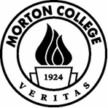 | MORTON COLLEGE  COMMUNITY COLLEGE DISTRICT NO. 527  COOK COUNTY, ILLINOIS
The Special Meeting scheduled for tomorrow, July 28, 2021, at 11:00 AM,

at Morton College, Room 107C, Building C, 3801 S. Central Avenue, Cicero, IL 60804, has been canceled.

